Exercise No:1

Date: 10/10/2020

**Aim:**

To create a python program to display calendar of the month from user’s input of year and month,if the year is not in 4 digits and month is not valid,then Invalid input statement is printed.

**Program:**

import calendar as cal

year=int(input("Enter the year:"))

month=int(input("Enter the month:"))

if(year>999 and year<10000):

if(month>=1 and month<=12):

print(cal.month(year,month))

else:

print("Invalid Input")

else:

print("Invalid Input")

**Link:**

[**http://103.53.53.18/mod/vpl/forms/submissionview.php?id=229&userid=1655**](http://103.53.53.18/mod/vpl/forms/submissionview.php?id=229&userid=1655)

**Output:**

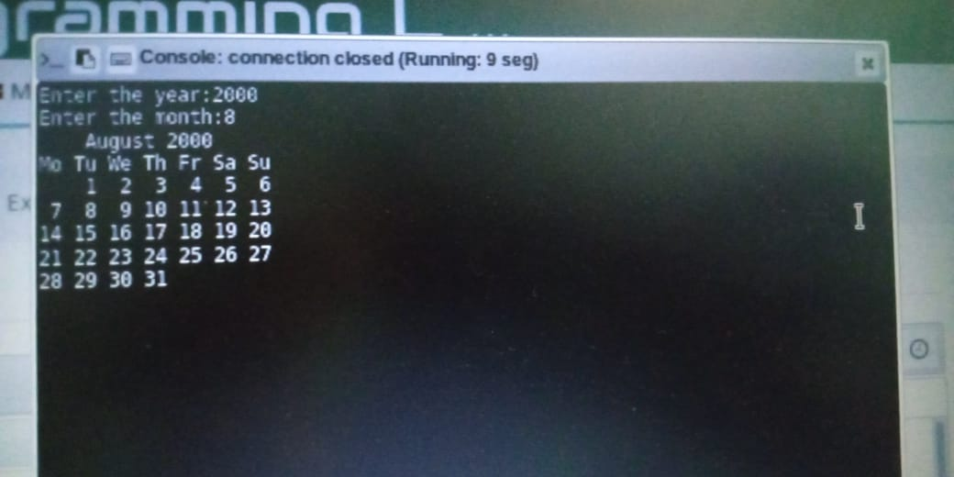

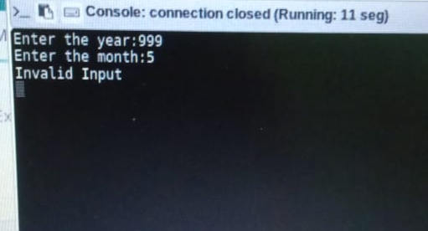

**Result:**

Thus, the program is executed and output is obtained.